**Exercise 3: Digging into DNS (marked, include in the lab report)**

In order to answer the following questions, you will make DNS queries using some of the query types you have encountered in the above exercise. Some questions require you to make multiple DNS queries. Before you proceed, read the manpage of dig (type man dig in the terminal). Make sure you understand how you can explicitly specify the following:

* nameserver to query
* type of DNS query to make (the default query types are those you saw in exercise 1)
* performing reverse queries

**Note:**Include the output of all the dig commands you have used in your answers.

To send a query to a particular name server (say x.x.x.x) you should use the following command:

dig @x.x.x.x hostname

Question 1. What is the IP address of [www.cecs.anu.edu.au](http://www.cse.unsw.edu.au/). What type of DNS query is sent to get this answer?

**Answer 1: The IP address is 150.203.161.98, the type of DNS query is A.**

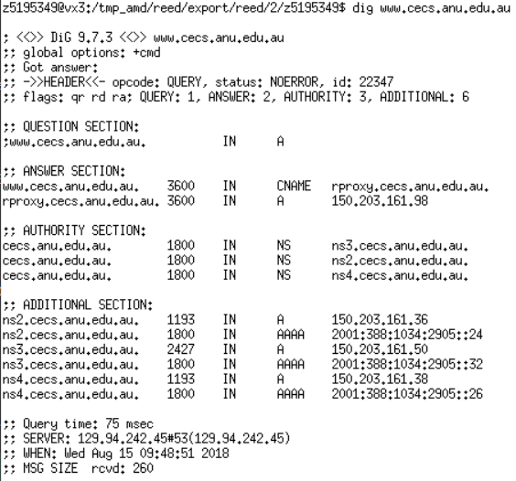

Question 2. What is the canonical name for the CECS ANU web server? What is its IP address? Suggest a reason for having an alias for this server.

**Answer 2: Observe the output above that the canonical name is rproxy.cecs.anu.edu.au. Its IP address is 150.203.161.98. Reason: sometimes a server may change its IP address, if we use ‘A’ record to record, we have to change our record when server’s IP address changes. However, ‘CNAME’ record just records domain name, so we don’t need to change our IP address when server’s IP address changes.**

**C:\Users\PGavin\AppData\Local\Temp\1534256428(1).png**

Question 3. What can you make of the rest of the response (i.e. the details available in the Authority and Additional sections)?

**Answer 3: The Authority sections show that some authority nameservers can be used (also means some resource record in type ‘NS’), and the Additional sections show the IP address (‘A’ is IPv4, and ‘AAAA’ is IPv6) of authority nameservers which above section shows. Also, in the end of the response, it shows other detail, like Query time (the time of executing this query), local server’s IP address, date and time.**

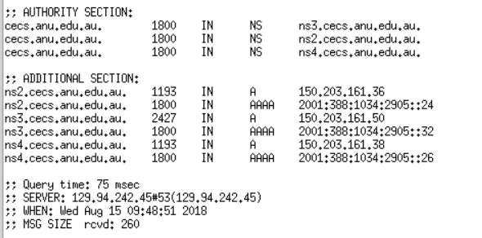

Question 4. What is the IP address of the local nameserver for your machine?

**Answer 4: Local nameserver’s IP address is 129.94.242.45**

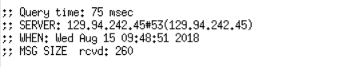

Question 5. What are the DNS nameservers for the “cecs.anu.edu.au” domain (note: the domain name is cecs.anu.edu.au and not[www.cecs.anu.edu.au](http://www.cse.unsw.edu.au/))? Find out their IP addresses? What type of DNS query is sent to obtain this information?

**Answer 5: The DNS nameservers are ns2.cecs.anu.edu.au, ns3.cecs.anu.edu.au, ns4.cecs.anu.edu.au, the IP addresses are 150.203.161.36(IPv4)/2001:388:1034:2905::24(IPv6), 150.203.161.50(IPv4)/2001:388:1034:2905::32(IPv6),150.203.161.38(IPv4)/2001:388:1034:2905::26(IPv6) respectively. The type is NS which means delegating a DNS zone to use the given authoritative name servers**

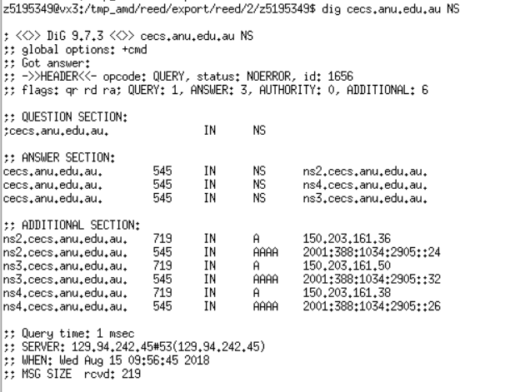

Question 6. What is the DNS name associated with the IP address 149.171.158.109? What type of DNS query is sent to obtain this information?

**Answer 6: For this, we use reverse DNS. When we observe the answer section, we can find that it has** [**www.engineering.unsw.edu.au**](http://www.engineering.unsw.edu.au) **which suggests that this machine hosts the website. Also, we can find the engplws008.ad.unsw.edu.au and engplws008.eng.unsw.edu.au which mean that the same server may be hosting some active directory services. The type is PTR (the most common use is for implementing reverse DNS lookups)**

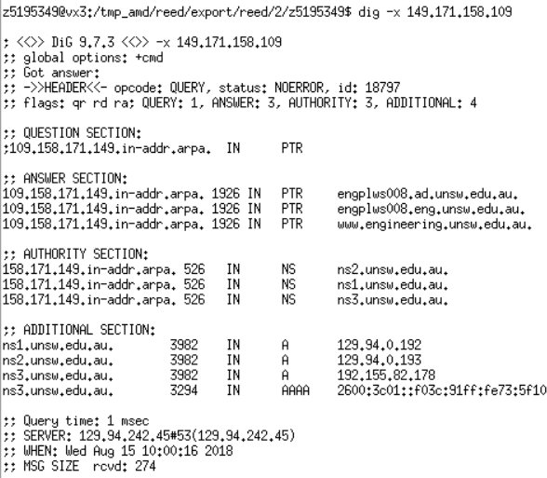

Question 7. Run dig and query the CSE nameserver (129.94.242.33) for the mail servers for Yahoo! Mail (again the domain name is yahoo.com, not [www.yahoo.com](http://www.yahoo.com/)). Did you get an authoritative answer? Why? (HINT: Just because a response contains information in the authoritative part of the DNS response message does not mean it came from an authoritative name server. You should examine the flags in the response to determine the answer)

**Answer 7: No, we didn’t get an authoritative answer because the flags do not contain ‘AA’, which means authoritative answer. This is because it has authority for only this domain we are in but not for the Yahoo domain.**

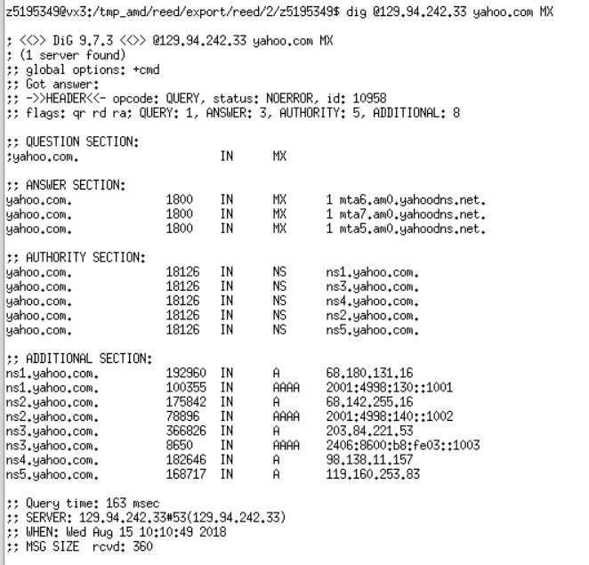

Question 8. Repeat the above (i.e. Question 7) but use one of the nameservers obtained in Question 5. What is the result?

**Answer 8: We can find the status is REFUSED, so we do not get a response. The reason could be to prevent some DNS attacks, these servers do not respond every query from Internet, they just respond some certain IP addresses (The network in ANU).**

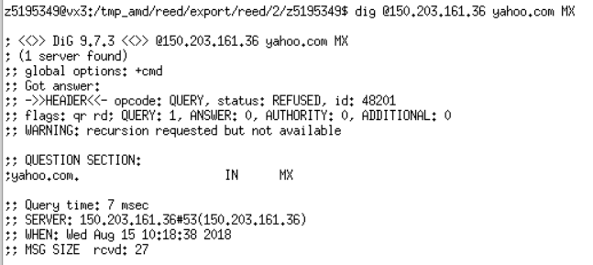

Question 9. Obtain the authoritative answer for the mail servers for Yahoo! mail. What type of DNS query is sent to obtain this information?

**Answer 9: We can use nameservers from yahoo.com in Q7. One of nameservers is ns1.yahoo.com, IP address is 68.180.131.16. The type is MX.**

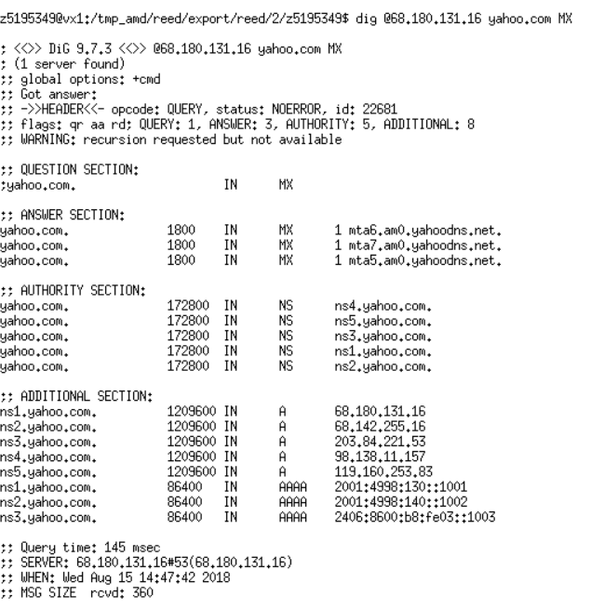

Question 10. In this exercise you simulate the iterative DNS query process to find the IP address of your machine (e.g. lyre00.cse.unsw.edu.au). First, find the name server (query type NS) of the "." domain (root domain). Query this nameserver to find the authoritative name server for the "au." domain. Query this second server to find the authoritative nameserver for the "edu.au." domain. Now query this nameserver to find the authoritative nameserver for "unsw.edu.au". Next query the nameserver of unsw.edu.au to find the authoritative name server of cse.unsw.edu.au. Now query the nameserver of cse.unsw.edu.au to find the IP address of your host. How many DNS servers do you have to query to get the authoritative answer?

**Answer 10: First, find root domain’s nameservers:**

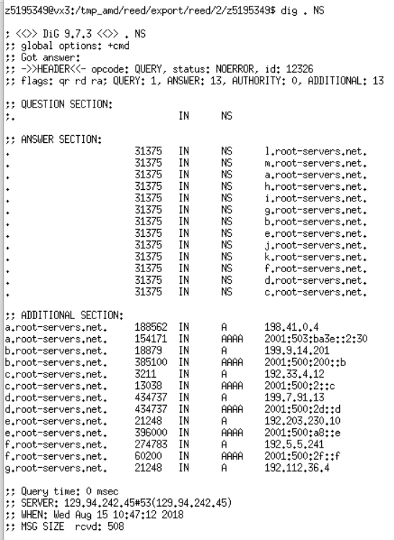

**Secondly, query ‘au.’ domain:**

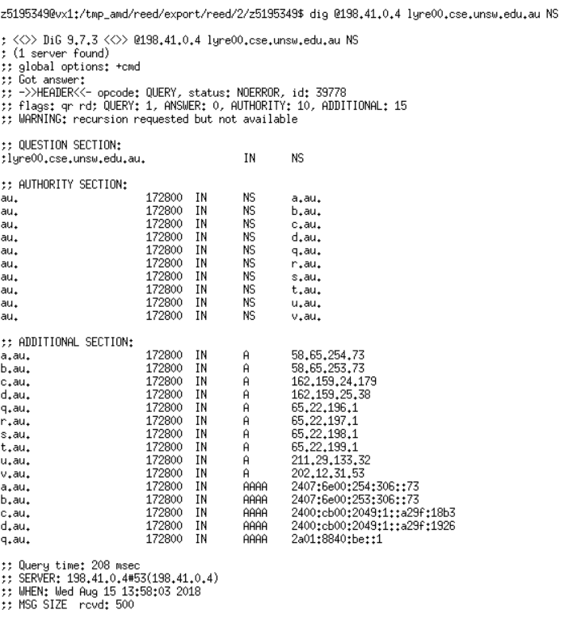

**Thirdly, query ‘edu.au.’ domain:**

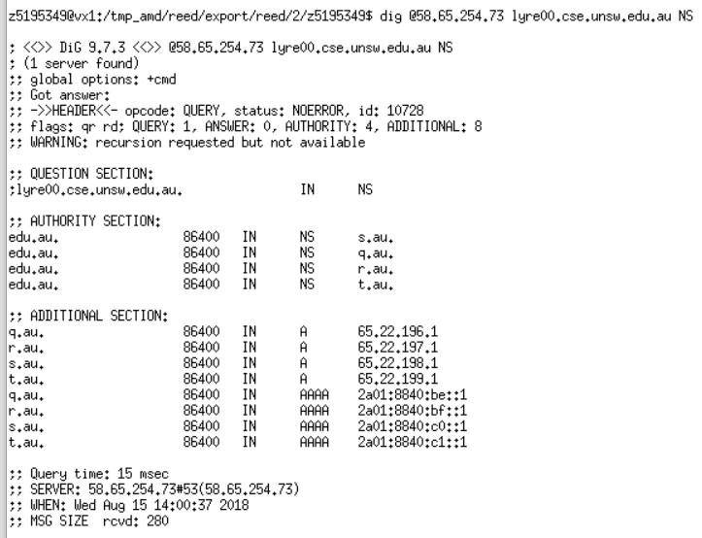

**And then, query ‘unsw.edu.au.’ domain:**

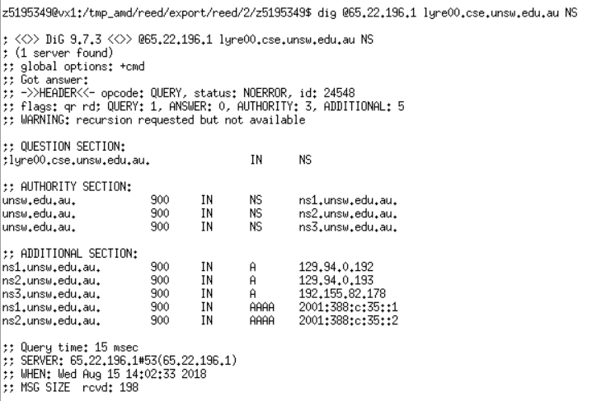

**Next, query ‘cse.unsw.edu.au.’ domain:**

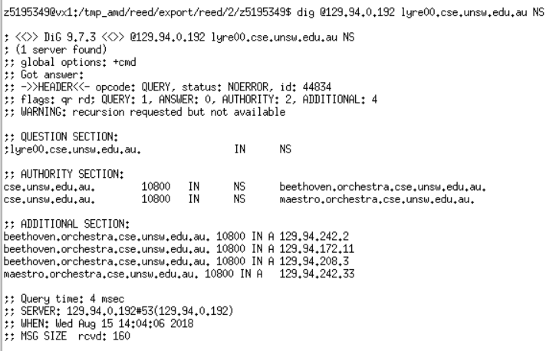

**Finally, we get ‘cse.unsw.edu.au’ domain’s servers above. Therefore, we can query one of them to get IP address of host lyre00.cse.unsw.edu.au. (Note that we use ‘A’ to query the IP address, not use ‘NS’.):**

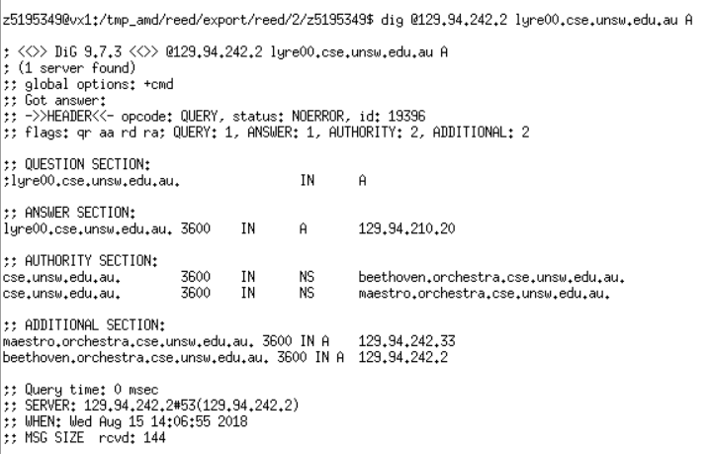

**The IP address of lyre00.cse.unsw.edu.au is 129.94.210.20. We had to query 5 DNS servers (a.root-servers.net, a.au, q.au, ns1.unsw.edu.au, maestro.orchestra.cse.unsw.edu.au).**

Question 11. Can one physical machine have several names and/or IP addresses associated with it?

**Answer 11: Yes, one physical machine can have several names and several IP addresses. This is because a physical machine can have many interfaces, and one interfaces can have several IP addresses (May be including some virtual IP addresses or using NAT to make servers’ different ports correspond to IP addresses (private addresses)). In addition, an IP address can have several hostnames.**

**(*) Exercise 4: A Simple Web Server**

**Note: Include your code in the lab report and demonstrate this exercise to your tutor in the lab slot.**

In this exercise, you will learn the basics of TCP socket programming: how to create a socket, bind it to a specific address and port, as well as send and receive an HTTP packet. You will also learn some basics of HTTP header format. You will develop a web server that handles one HTTP request at a time. Specifically, your web server should do the following:

(i) create a connection socket when contacted by a client (browser).

(ii) receive HTTP request from this connection. Your server should only process GET request. You may assume that only GET requests will be received.

(iii) parse the request to determine the specific file being requested.

(iv) get the requested file from the server's file system.

(v) create an HTTP response message consisting of the requested file preceded by header lines.

(vi) send the response over the TCP connection to the requesting browser.

(vii) If the requested file is not present on the server, the server should send an HTTP “404 Not Found” message back to the client.

(viii) the server should listen in a loop, waiting for next request from the browser.

You don't have to deal with any other error conditions.

Your program should be called WebServer.c or WebServer.java or WebServer.py.

You should write the server so that it executes with the following command:

$java WebServer port (for Java)

$WebServer port (for C)

$python WebServer.py port (for Python)

where port is the port No your Web server will be listening on.

1. Place a simple HTML file (index.html, without any hyperlinks) in the same directory as the server program. A sample index.html file is provided [here](https://webcms3.cse.unsw.edu.au/COMP3331/18s2/resources/20132). Run the server program as indicated above. Open a web browser on the same machine. Type the following url: http://127.0.0.1:port/index.html where port is the port number the server listens on. If you forget to include the port number, the browser will assume the default port of 80. The browser should display the content of index.html.

2. Place multiple image files (.png) in the same directory as the server program. Run the server program as indicated above. Open a web browser on the same machine. Type http://127.0.0.1:port/myimage.png

where port is the port number the server listens on and myimage.png is one of the image files present in the server's directory. The browser should display the image.

 3. Now try and request for an object that does not exist in the server directory, e.g.: http://127.0.0.1:port/bio.html . The browser should display the 404 error message.

Note that you cannot use any of the pre-made web servers available in different programming languages.

**Visit: http://127.0.0.1:8800/index.html**

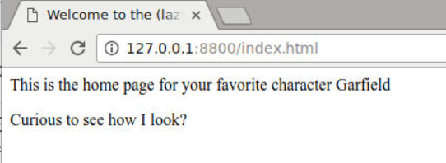

**Visit: http://127.0.0.1:8800/myimage.png**

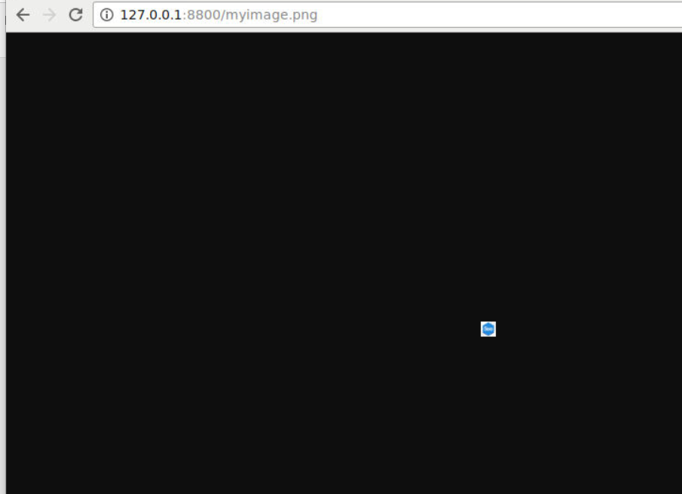

**Visit: http://127.0.0.1:8800/bio.html**

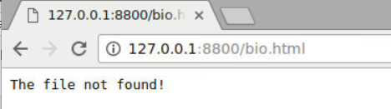

**This is my code:**

import socket

import sys

from multiprocessing import Process

def handle_client(client_socket):

"""handle client connection request"""

request_data = client_socket.recv(1024)

print(request_data)

request_lines = request_data.splitlines()

for line in request_lines:

print(line)

# 'GET /filename HTTP/1.1'

if len(request_lines[0]):

request_start_line = request_lines[0].decode("utf-8")

# get filename, GET /index.html HTTP/1.1

get_file_name = str(request_start_line).split(' ')

if get_file_name[0] != "GET":

print("Incorrect request!")

return

else:

file_name = get_file_name[1][1:]

# open file and read

try:

file = open(file_name, "rb")

except IOError:

response_start_line = "HTTP/1.1 404 Not Found\r\n"

response_heads = "Server: My python server\r\n"

response_body = "The file not found!"

response = response_start_line + response_heads + "\r\n" + response_body

client_socket.sendall(bytes(response))

else:

file_data = file.read()

file.close()

response_start_line = "HTTP/1.1 200 OK\r\n"

response_heads = "Server: My python server\r\n"

if file_name.find('.html') > 0: # html or png

print(file_name.find('.html'))

response_content_type = "Content-Type:text/html\r\n"

response_body = file_data.decode("utf-8")

response = response_start_line + response_heads + response_content_type + "\r\n" + response_body

client_socket.sendall(bytes(response))

else:

response_content_type = "Content-Type:image/png\r\n"

response_body = file_data

response = response_start_line + response_heads + response_content_type + "\r\n"

client_socket.sendall(bytes(response))

client_socket.sendall(response_body)

client_socket.close()

if __name__ == "__main__":

s = socket.socket(socket.AF_INET, socket.SOCK_STREAM) # tcp socket

s.setsockopt(socket.SOL_SOCKET, socket.SO_REUSEADDR, 1)

# host = socket.gethostname() # get localhost

if len(sys.argv) == 2:

port = int(sys.argv[1])

else:

port = 80

s.bind(("", port)) # 127.0.0.1 port

s.listen(5)

while True:

c, addr = s.accept() # accept from client

handle_client_process = Process(target=handle_client, args=(c,)) # build function

handle_client_process.start()

c.close()